

**Western Australian Certificate of Education**

**ATAR course examination, 2020**

**Question/Answer Booklet**

11 PHYSICS

Name

**Test 1 - Motion**

|  |  |  |  |  |  |  |  |  |  |  |
| --- | --- | --- | --- | --- | --- | --- | --- | --- | --- | --- |
| Student Number: In figures |  |  |  |  |  |  |  |  |  |  |

**Mark: $\frac{}{\text{3}\text{7}}$**  In words

#### Time allowed for this paper

Reading time before commencing work: five minutes

Working time for paper: fifty minutes

**Materials required/recommended for this paper**

To be provided by the supervisor

This Question/Answer Booklet

Formulae and Data Booklet

***To be provided by the candidate***

Standard items: pens, (blue/black preferred), pencils (including coloured), sharpener, correction fluid/tape, eraser, ruler, highlighters

Special items: non-programmable calculators satisfying the conditions set by the School Curriculum and Standards Authority for this course

**Important note to candidates**

No other items may be taken into the examination room. It is your responsibility to ensure that you do not have any unauthorised notes or other items of a non-personal nature in the examination room. If you have any unauthorised material with you, hand it to the supervisor before reading any further.

**Structure of this paper**

|  |  |  |  |  |  |
| --- | --- | --- | --- | --- | --- |
| Section | Number of questions available | Number of questions to be answered | Suggested working time  (minutes) | Marks available | Percentage of exam |
| Section One:  Short Answers |  |  |  |  |  |
| Section Two:  Problem-solving | 4 | 4 | 50 | 37 | 100 |
| Section Three:  Comprehension |  |  |  |  |  |
|  |  |  |  | **Total** | 100 |

**Instructions to candidates**

1. The rules for the conduct of examinations at Holy Cross College are detailed in the College Examination Policy*.* Sitting this examination implies that you agree to abide by these rules.

2. Write your answers in this Question/Answer Booklet.

3. Working or reasoning should be clearly shown when calculating or estimating answers.

4. You must be careful to confine your responses to the specific questions asked and to follow any instructions that are specific to a particular question.

5. Spare pages are included at the end of this booklet. They can be used for planning your

responses and/or as additional space if required to continue an answer.

• Planning: If you use the spare pages for planning, indicate this clearly at the top of the page.

• Continuing an answer: If you need to use the space to continue an answer, indicate in the original answer space where the answer is continued, i.e. give the page number.

Fill in the number of the question(s) that you are continuing to answer at the top of the page.

6. Answers to questions involving calculations should be ***evaluated and given in decimal***

***form*.** It is suggested that you quote all answers to ***three significant figures***, with the

exception of questions for which estimates are required. Despite an incorrect final result, credit may be obtained for method and working, providing these are ***clearly and legibly set out***.

7. Questions containing the instruction "estimate" may give insufficient numerical data for their solution. Students should provide appropriate figures to enable an approximate solution to be obtained. Give final answers to a maximum of two significant figures and include appropriate units where applicable.

8. Note that when an answer is a vector quantity, it must be given with magnitude and direction.

9. In all calculations, units must be consistent throughout your working.

1. A boat head N30.0°W at 8.00 kmh-1 from a jetty for 30.0 minutes before changing course to head due north at 6.00 kmh-1 for 20.0 minutes before arriving at a small island.

(a) Calculate the displacement of the boat (in metres) after 50.0 minutes. Include a vector diagram in your working. (5 marks)

(b) Determine the average velocity of the boat for the journey. (3 marks)

2. A primary school student designed the coin for the Australia-New Zealand day-night test at Optus Stadium. He was allowed to toss the coin for the start of the match and flipped it upwards at 6.30 ms-1 from 1.40 m above the pitch. It fell onto the pitch and the captain of New Zealand won the toss.

(a) How high did the coin rise above the pitch? (5 marks)

(b) What was the impact velocity of the coin onto the pitch? (3 marks)

(c) How long was the coin in the air? (3 marks)

(d) The student made the coin spin. In reality, how would this affect your calculations for

(a) - (c)? Explain your answer. (2 marks)

3. The speed-time graph below describes a 50-second car journey, assumed to be in a straight line.

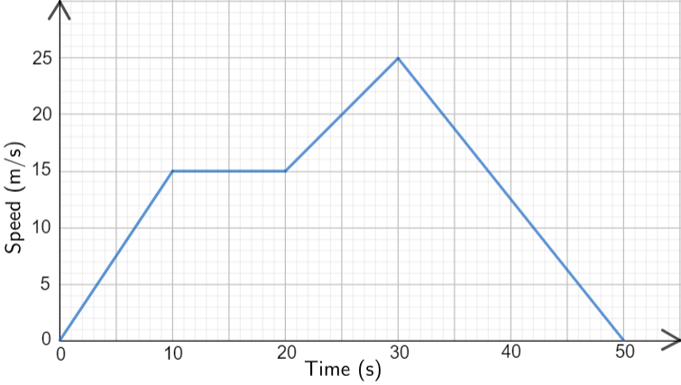

(a) Determine the displacement of the car using the graph. (4 marks)

(b) Draw an acceleration - time graph for the motion with clearly-marked axes.

(5 marks)



4. A plane is flying at 655 kmh-1 in level flight. It needs to set a heading from this point to land at an airport 1.10 x 103 km away on heading N35.0°E. A wind is blowing at 155 kmh-1 from the east.

(a) Determine the heading that the plane must take in order to reach the airport. Drawing a vector diagram is recommended. (4 marks)

(b) How long will it take the plane to reach the airport? Ignore any change in altitude as the plane descends to land. (3 marks)